A

PROJECT REPORT

ON

***“ BUSINESS MANAGEMENT “***

*-Submitted To-*



*In partial fulfillment for the degree of*

**BACHELOR IN BUSINESS ADMINISTRATION (COMPUTER APPLICATION)**

*-Submitted By-*

**Mr. khilari Sairaj & Mr. Hinge Atharva**

*-Under The Guidance Of-*

*Prof. Surve A. R. & Prof. Kakade S. V.*



Through

*Gramonnati Mandal’s*   
 ARTS, COMMERCE AND SCIENCE COLLEGE, NARAYANGAON

(B.B.A. /B.B.A.(C.A.) DEPARTMENT) For The Year [2024-2025]

**BUSINESS**

**MANAGEMENT**

**Gramonnati Mandal’s**

**ARTS, COMMERCE & SCIENCE COLLEGE,**

**NARAYANGAON**

**Tal. - Junnar, Dist. -Pune 410504**



**Department of B.B.A. & B.B.A.(C.A.)**

**CERTIFICATE**

This is to certify that Mr./Miss **Mr. khilari Sairaj** Seat No. ………. and Mr./Miss **Mr. Hinge Atharva** Seat No………….. during the academic year 2024-2025 in the partial fulfillment of B.B.A.(C.A.) project examination conducted by Savitribai Phule Pune university, Pune.

**Internal Examiner External Examiner**

**Project Guide Prof. D. M. Wagh Prof. S.B. Kudekar**

**ACKNOWLEDGEMENT**

I wish to thank the Principal Prof. Dr. A.B. Kulkarni and Co-ordinator Prof. Kudekar S. B. of my college for permitting me to use all the facilities available in the institution for my project work. I would also like to thank to the Head of the BBA/BBA(CA) department Prof. Wagh D.M. the teaching faculty and all the non- teaching staff of my college for their support in completing the work successfully.

I am grateful to my Internal Guide Prof. Kakade S.V. For her encouragement, guidance and supervision of my project work during the year. I express my thankfulness to them. I must acknowledge the support given to this project by others teachers and non-teaching without which it would have been difficult to complete the work in time.

My classmates have been of great help to me during the project work. My ideas were shaped and refined progressively through my discussions with them time to time. I cannot miss to thank them all. There were some persons who were not directly but indirectly but indirectly involved in my preparatory/practical work. I heartily appreciate their contribution and thank them too.

Date: Signature:

Khilari sairaj  
Hinge Atharva

Class: SYBBA(CA)

Year: 2024-2025

INDEX

|  |  |  |
| --- | --- | --- |
| Sr. No | Title | Page no |
| 1 | Introduction |  |
| 2 | Scope of System |  |
| 3 | Proposed of System |  |
| 4 | System Analysis |  |
| 5 | Fact Finding Techniques |  |
| 6 | Feasibility Study |  |
| 7 | Hardware & Software Requirement |  |
| 8 | System Design |  |
| 9 | Entity Relationship Diagram |  |
| 10 | File Designing |  |
| 11 | Advantages & Disadvantages |  |
| 12 | Future Enhancement |  |
| 13 | Bibliography |  |

INTRODUCTION

The business management landing page project is designed to create a visually appealing and user-friendly online presence for small to medium-sized businesses. This project aims to leverage modern web technologies such as HTML, CSS, and JavaScript to enhance customer engagement and improve brand visibility.

In today's digital age, having a professional website is crucial for businesses to reach a wider audience and stay competitive. The landing page will serve as a central hub for showcasing services, sharing updates, and facilitating communication with potential clients.

Key features of the project include:

* **Responsive Design:** Ensures compatibility across various devices and screen sizes.
* **Interactive Elements:** Incorporates animations and dynamic content to enhance user experience.
* **SEO Optimization:** Includes meta tags and keywords to improve search engine rankings.

The introduction sets the stage for understanding the project's objectives and its role in modern business strategies.

**SCOPE OF SYSTEM**

The scope of the business management landing page system encompasses several key functionalities and objectives:

User Interface (UI): A clean and intuitive design that guides users through the site's features.

Navigation: Easy-to-use menus and links to facilitate quick access to information.

Content Management: Ability to update content without requiring extensive technical knowledge.

Contact Form: A simple form for visitors to send inquiries or feedback.

Social Media Integration: Links to social media platforms to expand the business's online presence.

The system is designed to cater to businesses looking to establish or enhance their digital footprint. It focuses on providing a seamless user experience while ensuring that the site remains easy to manage for non-technical users.

The scope also includes considerations for scalability and adaptability, allowing the system to grow with the business's needs.

PROPOSED SYSTEM

The proposed system for the business management landing page is built around creating a modern, engaging, and accessible online platform. It leverages the latest web technologies to ensure a high-quality user experience:

1. **Front-end Development:** Utilizes HTML5, CSS3, and JavaScript to create interactive elements and responsive layouts.
2. **Back-end Integration:** Optional integration with a simple database or CMS for managing content dynamically.
3. **Design Principles:** Follows best practices in UI/UX design to ensure clarity and navigation ease.
4. **Accessibility Features:** Incorporates features like high contrast mode and screen reader compatibility.

The proposed system aims to address common challenges faced by businesses in creating an effective online presence, such as low engagement and poor visibility. By focusing on user experience and accessibility, the system ensures that it caters to a broad audience.

SYSTEM ANALYSIS

System analysis involves examining the current state of business landing pages and identifying areas for improvement. This includes:

1. Problem Identification: Many existing landing pages lack interactivity, leading to low user engagement.
2. Market Analysis: Competitor analysis reveals opportunities for differentiation through design and functionality.
3. User Needs Assessment: Surveys and interviews highlight the importance of ease of use and accessibility.

The analysis phase also involves evaluating existing solutions and technologies to determine the best approach for the project. This includes assessing the strengths and weaknesses of different web development frameworks and tools.

By understanding the needs of both businesses and users, the system analysis provides a solid foundation for designing an effective landing page.

**Fact-Finding Techniques**

Fact-finding techniques are crucial in gathering data and insights necessary for designing an effective business management landing page. These techniques include:

1. **Interviews:** Conducted with business owners to understand their requirements and challenges.
2. **Surveys:** Distributed to potential users to gather feedback on preferred features and design elements.
3. **Observation:** Analyzing competitor websites to identify best practices and areas for differentiation.
4. **Literature Review:** Examining existing research on web design principles and user behavior.

These techniques help in creating a comprehensive understanding of the project's requirements and ensure that the final product meets the needs of its target audience.

**FEASIBILIITY STUDY**

A feasibility study assesses whether the proposed system is viable in terms of technical, economic, operational, and legal factors:

1. Technical Feasibility: The use of widely available technologies like HTML, CSS, and JavaScript ensures that the system can be developed and maintained with ease.
2. Economic Feasibility: The project's reliance on open-source tools and minimal infrastructure keeps costs low.
3. Operational Feasibility: The system is designed to be user-friendly, allowing non-technical users to manage and update content.
4. Legal Feasibility: Ensures compliance with privacy laws and accessibility standards.

The feasibility study confirms that the project is practical and achievable within the given constraints.

**SOFTWARE & HARDWARE REQUIRNMENTS**

To develop and maintain the business management landing page, the following hardware and software are required:

Hardware:

* Computer: A laptop or desktop with at least 8GB RAM and 500GB storage.
* Internet Connection: A stable internet connection for testing and deployment.

Software:

* Code Editor: Visual Studio Code or similar for writing and editing code.
* Web Browsers: Google Chrome, Mozilla Firefox, and Safari for testing compatibility.
* Version Control System: Git for tracking changes and collaborating with team members.
* Design Tools: Adobe XD or Figma for creating wireframes and prototypes.

These tools ensure efficient development and maintenance of the landing page.

**SYSTEM DESIGN**

The system design outlines the architecture and layout of the business management landing page:

Wireframes: Initial sketches of the page layout to visualize the structure.

Prototypes: Interactive models to test user flow and navigation.

User Interface (UI) Design: Final design elements such as colors, typography, and graphics.

User Experience (UX) Design: Ensures that the site is intuitive and easy to navigate.

The design phase involves creating a visually appealing and user-friendly interface that aligns with the project's objectives.

**Entity Relationship Diagram (ERD)**

An Entity Relationship Diagram (ERD) illustrates the relationships between different entities in the system. For a business management landing page, key entities might include:

1. **Users:** Visitors to the site.
2. **Contact Form Submissions:** Data collected from users through the contact form.
3. **Social Media Links:** Connections to external social media platforms.

The ERD helps in understanding how these entities interact and how data flows within the system.

**FILE DESIGNING**

File designing involves organizing the structure of the project's files and directories. A typical structure might look like this:

/project-folder

/css

- styles.css

- responsive.css

/js

- script.js

- animations.js

/images

- logo.png

- background.jpg

/fonts

- font1.ttf

- font2.ttf

index.html

contact.html

about.html

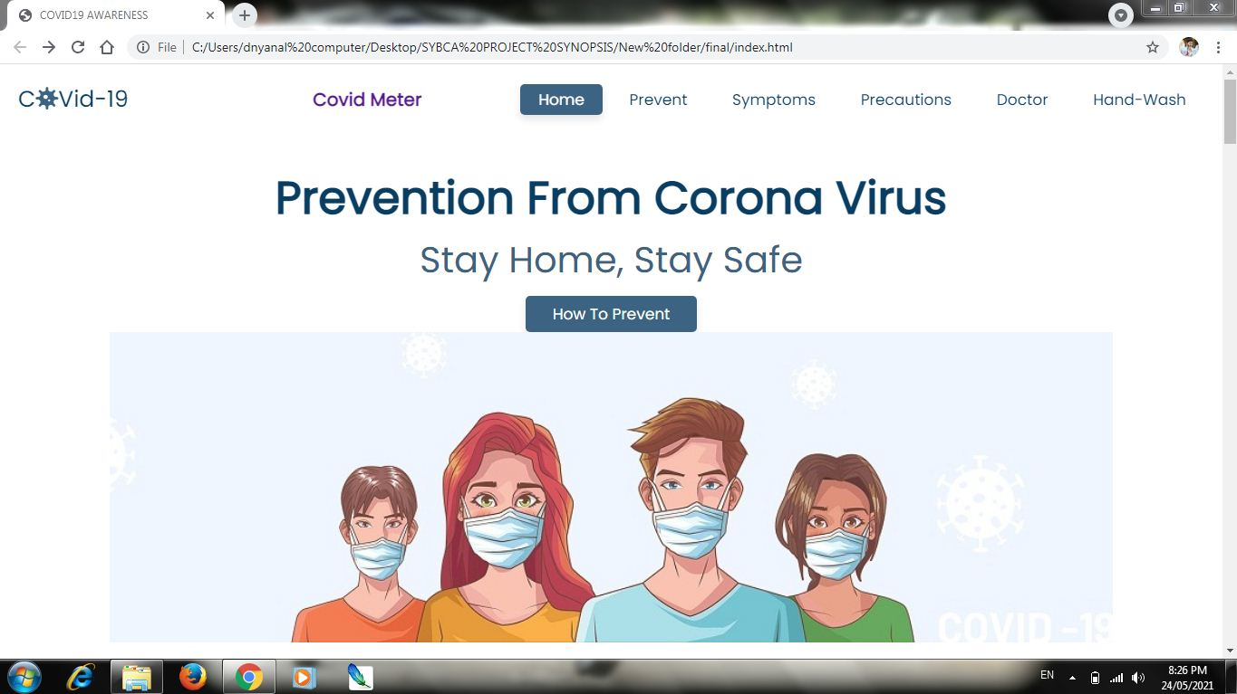

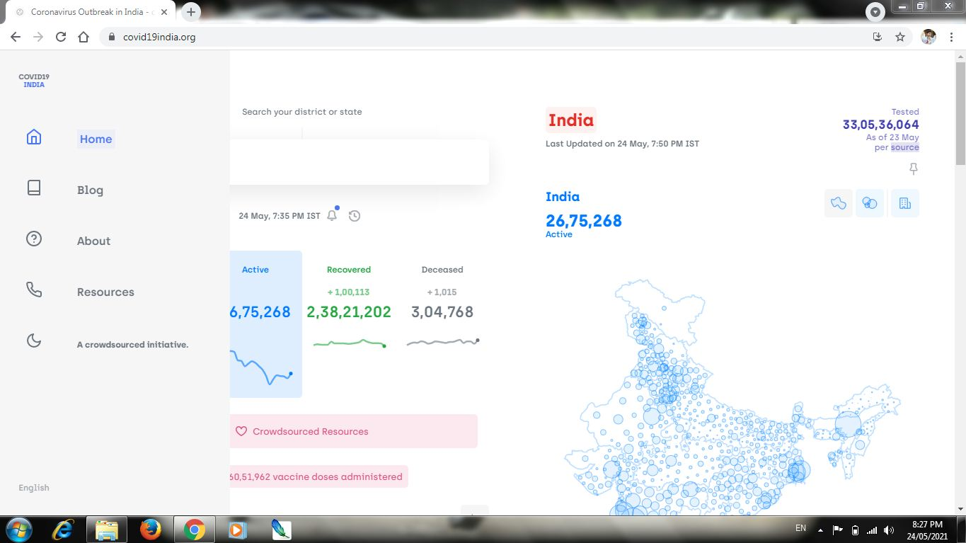

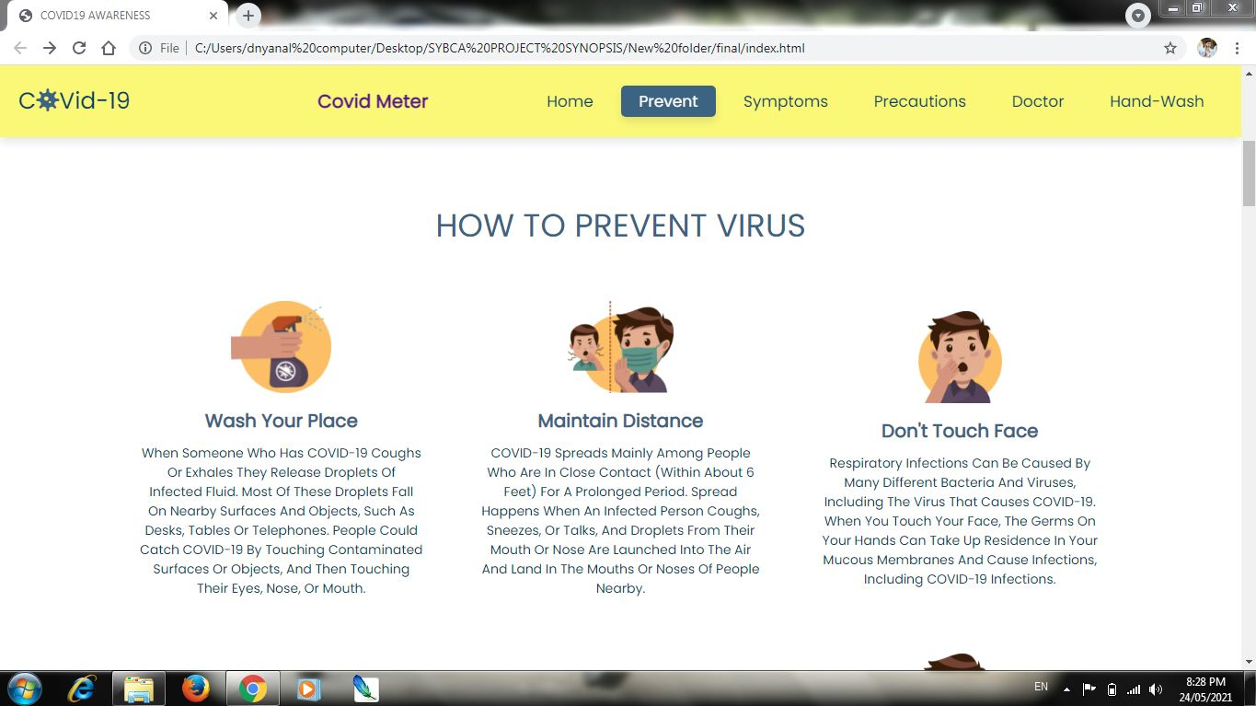

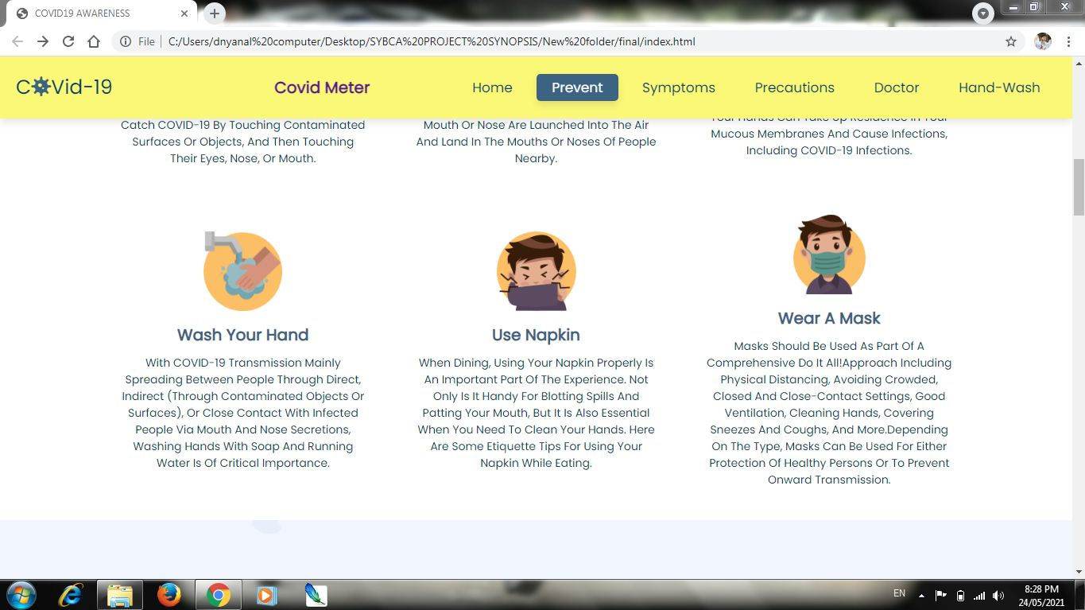

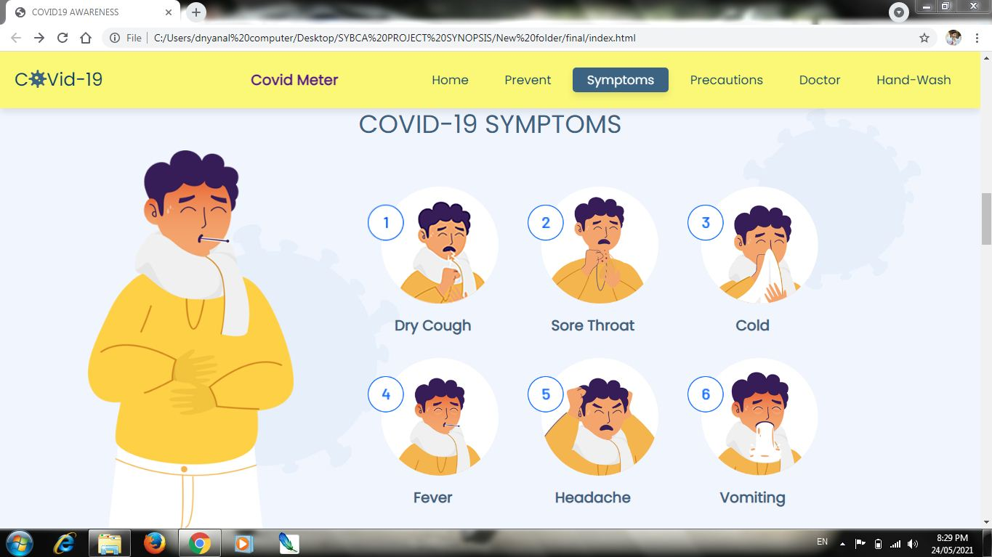

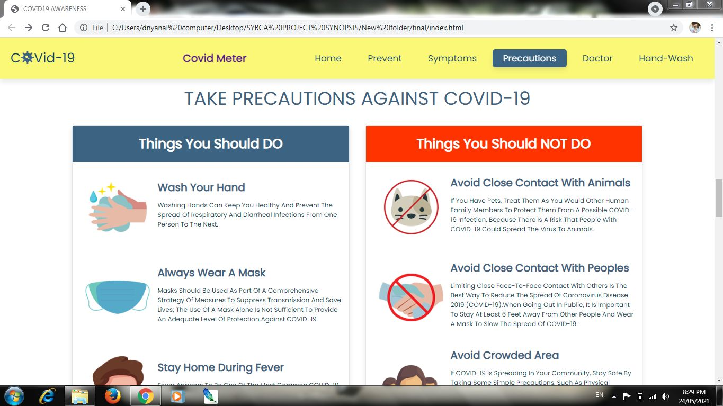

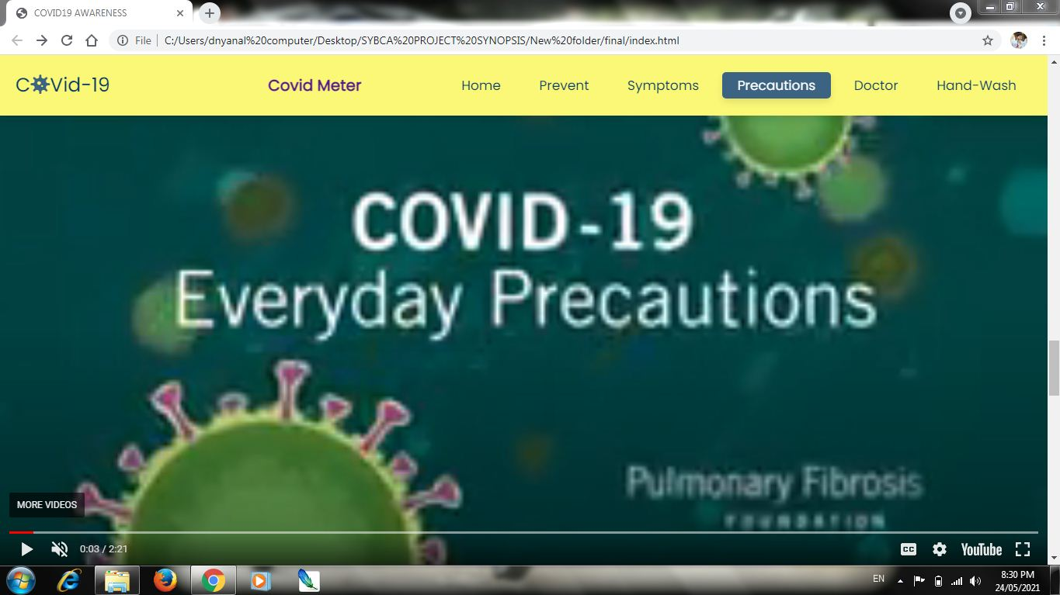

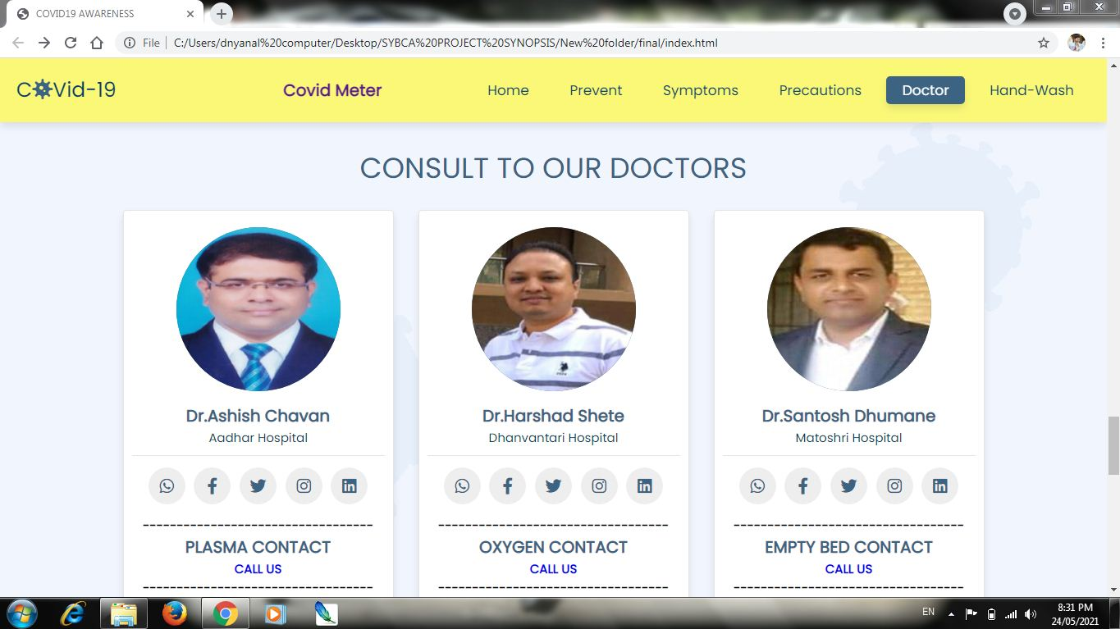

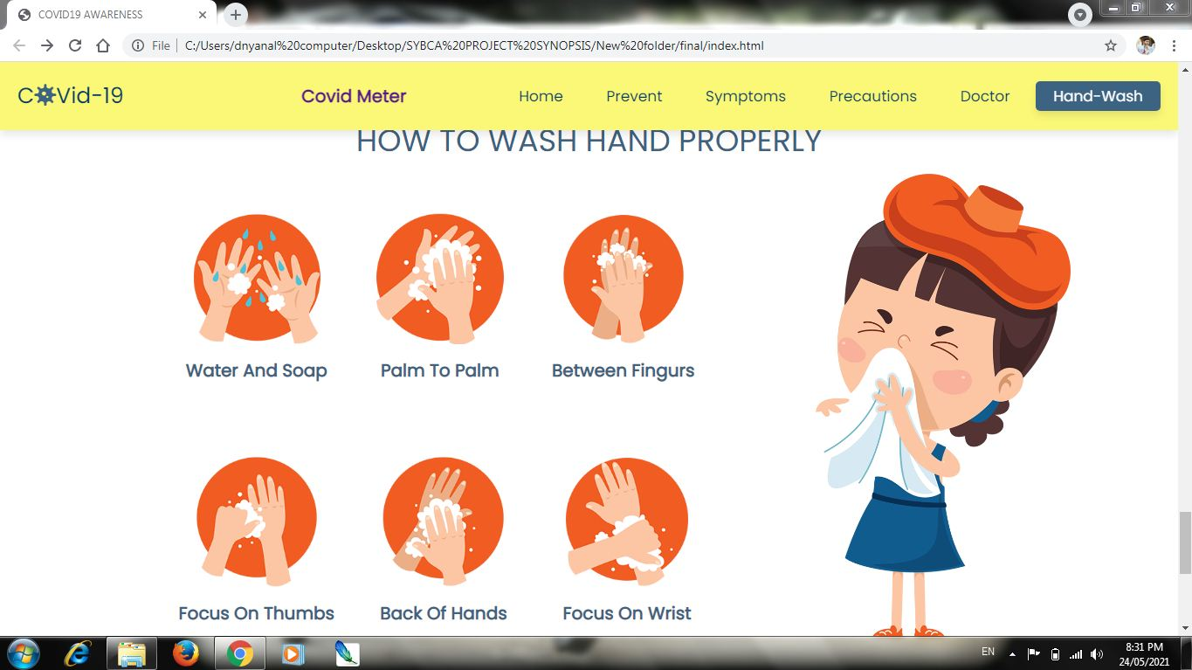

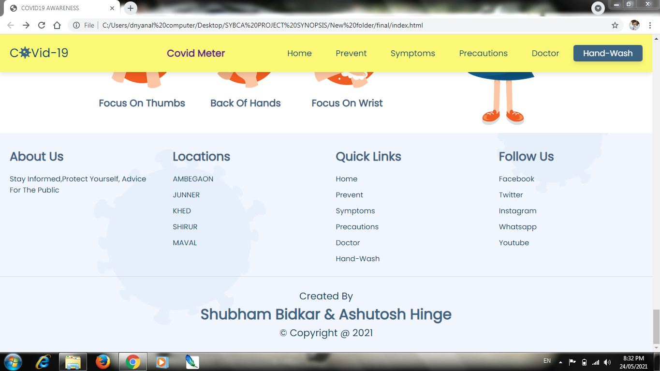

**ADVANTAGES & DISADVANTAGES OF THE SYSTEM**

Advantages:

1. Enhanced Visibility: Increases the business's online presence.
2. Improved Engagement: Interactive design elements encourage user interaction.
3. Cost-Effective: Utilizes open-source technologies to reduce costs.
4. Easy Maintenance: Designed for non-technical users to update content.

Disadvantages:

1. Initial Development Time: Requires time to design and develop.
2. Regular Updates: Needs periodic updates to stay relevant and secure.
3. Technical Expertise: Initial setup may require technical knowledge.

Understanding both the advantages and disadvantages helps in making informed decisions about the project.

**FUTURE ENHANCEMENT**

Future enhancements for the business management landing page could include:

1. **Content Management System (CMS):** Integration with a CMS like WordPress for easier content management.
2. **Blog Section:** Adding a blog to facilitate content marketing and SEO.
3. **Analytics Tools:** Incorporating Google Analytics to track user behavior and optimize the site.
4. **E-commerce Integration:** Adding e-commerce functionality for businesses that sell products online.

These enhancements can further improve the site's functionality and user experience.

**BIBLIOGRAPHY**

The bibliography includes references used during the project's research phase:

* Google
* https://fonts.google.com/specimen/Pop...
* https://cdnjs.com/libraries/jquery
* https://material.io/tools/icons/
* Web Development Tutorials**:** Resources like W3Schools and MDN Web Docs.
* Competitor Analysis Reports: Studies on successful business landing pages.
* User Feedback Surveys: Data collected from surveys and interviews with potential users.
* Literature on Web Design Principles: Books and articles on UI/UX design best practices.

**THANK YOU…**